Apache Hive vs Apache Pig
Apache Hive and Apache Pig are similar in that they both provide abstractions to simplify working with HDFS and distributed processing. However, they serve slightly different purposes and have different strengths. Here's a detailed comparison:
Similarities
- Abstraction:
  - Both Hive and Pig abstract the complexity of writing low-level MapReduce jobs, allowing users to write higher-level code that gets translated into MapReduce or other types of distributed processing tasks.
- Integration with Hadoop:
  - Both tools are designed to work seamlessly with Hadoop, leveraging HDFS for storage and MapReduce (or other execution engines) for processing.
- Data Processing:
  - They are both used for processing large datasets stored in HDFS. They provide functionalities to load, transform, and analyze data.
Differences
- Language:
  - Hive: Uses HiveQL, a SQL-like query language. It is more suitable for users with an SQL background and is often used for structured data analysis and reporting.
  - Pig: Uses Pig Latin, a procedural data flow language. It is designed to be more flexible and can handle both structured and semi-structured data. Pig Latin scripts can be more concise for complex data transformations.
- Use Cases:
  - Hive: Often used for data warehousing, reporting, and querying large datasets with a familiar SQL-like interface. It is well-suited for tasks that require complex queries and ad-hoc analysis.
  - Pig: Commonly used for ETL (Extract, Transform, Load) tasks, data preprocessing, and data pipeline development. It is favored for tasks that involve complex data transformations and handling of semi-structured data.
- Execution Engines:
  - Hive: Originally used MapReduce but now also supports Apache Tez and Apache Spark for better performance and lower latency.
  - Pig: Primarily uses MapReduce but also supports execution on Apache Tez for performance improvements.
- Data Schema:
  - Hive: Requires a schema to be defined for the data (schema-on-write). It uses a metastore to manage schema information and metadata.
  - Pig: Is more flexible with schema and can work with data that is not strictly structured (schema-on-read). It allows for more dynamic handling of data formats.
- Performance:
  - Hive: Can be optimized for query performance, especially with the use of execution engines like Tez or Spark. It includes features like query optimization and indexing.
  - Pig: Generally has a different focus on performance optimization. While it can be efficient for certain data transformation tasks, it may not always match Hive’s performance for complex queries.
Example Comparisons
Hive Example:
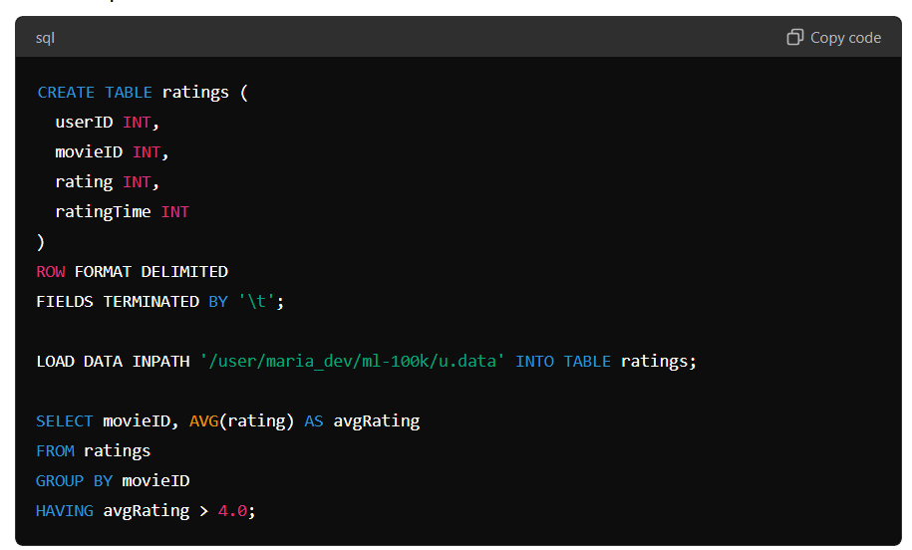
CREATE TABLE ratings (
userID INT,
movieID INT,
rating INT,
ratingTime INT
)
ROW FORMAT DELIMITED
FIELDS TERMINATED BY '\t';
LOAD DATA INPATH '/user/maria_dev/ml-100k/u.data' INTO TABLE ratings;
SELECT movieID, AVG(rating) AS avgRating
FROM ratings
GROUP BY movieID
HAVING avgRating > 4.0;
Pig Example:
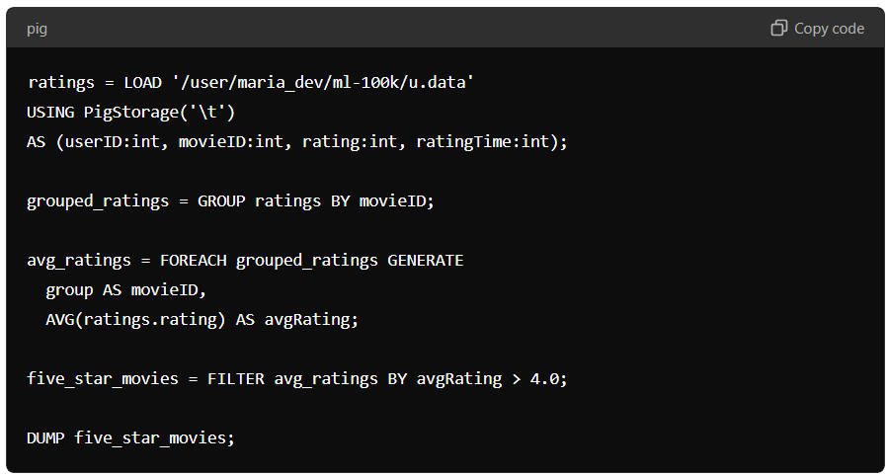
ratings = LOAD '/user/maria_dev/ml-100k/u.data'
USING PigStorage('\t')
AS (userID:int, movieID:int, rating:int, ratingTime:int);
grouped_ratings = GROUP ratings BY movieID;
avg_ratings = FOREACH grouped_ratings GENERATE
group AS movieID,
AVG(ratings.rating) AS avgRating;
five_star_movies = FILTER avg_ratings BY avgRating > 4.0;
DUMP five_star_movies;
When to Use Hive or Pig
- Use Hive if:
  - You are more comfortable with SQL.
  - You need to perform complex queries, reporting, and analysis.
  - Your use case involves a data warehouse or structured data.
- Use Pig if:
  - You need to perform complex data transformations and preprocessing.
  - You are dealing with semi-structured or unstructured data.
  - You prefer a more flexible and procedural scripting approach.
Conclusion
Hive and Pig both simplify working with HDFS and distributed processing, but they are tailored for different types of data processing tasks. Hive is better suited for structured data analysis using a SQL-like interface, while Pig is more flexible for complex data transformations and handling semi-structured data. The choice between Hive and Pig depends on the specific requirements of your data processing tasks and the expertise of your team.

